Globalization Field Trip Itinerary
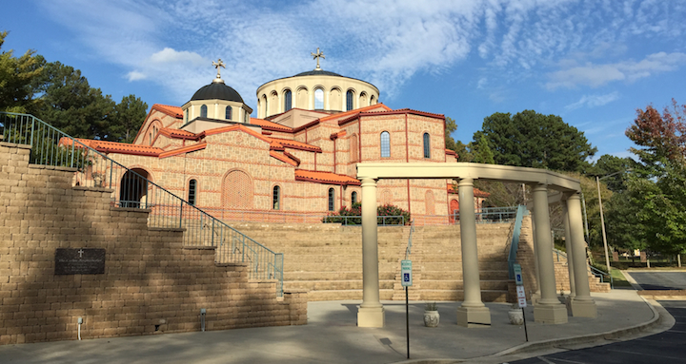
8:40 a.m. Holy Transfiguration Greek Orthodox Church
3431 Trickum Road
Marietta, GA 30066

Tel. 770-924-8080

10:15 a.m. Al-Farooq Masjid
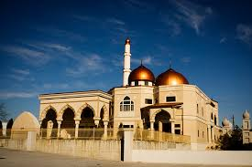
442 14th Street NW
Atlanta, GA 30318
(404) 874-7521

11:00 a.m. William Breman Jewish Heritage Museum
“Eighteen Artifacts: The Story of Jewish Atlanta”
Auditorium with Docent Responding to Questions
1440 Spring St NW
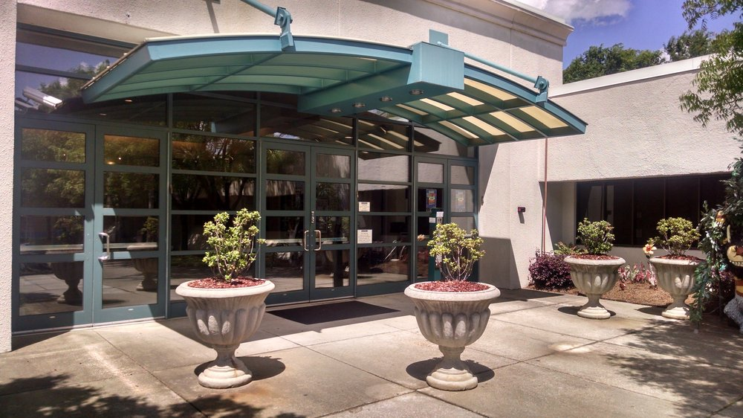
Atlanta, GA 30309
(678) 222-3700

12:20 p.m. The Imperial Fez Restaurant, Authentic Moroccan Cuisine
Nicola (owner and host) will discuss Lebanese food, culture, and dancing.
2285 Peachtree Rd #102
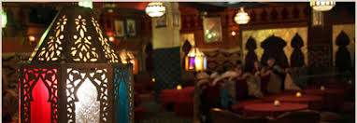
Atlanta, GA 30309
(404) 351-0870

2:10 p.m. Board coach bus for return to Pope, arrive by 3:10 p.m.

