Print Works Consulted
Open Noodletools Open “My Project” Open “Sources” from Dashboard

Click on “Print/Export” Select “Formatting Options” from menu

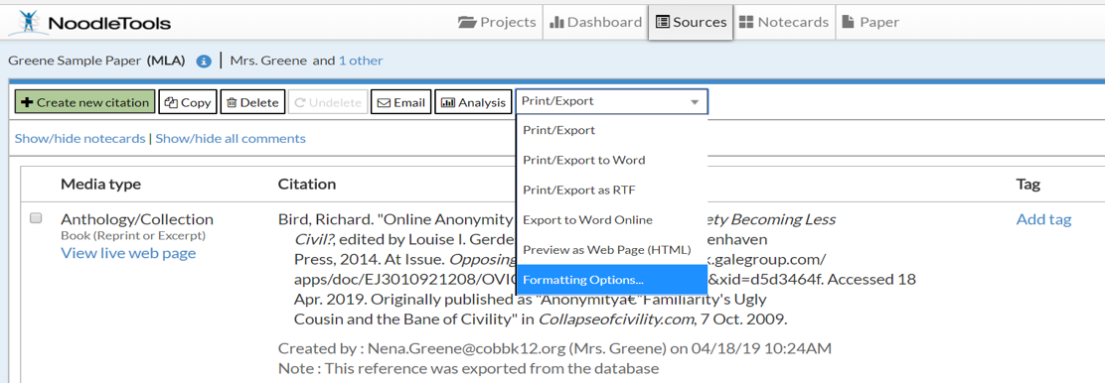

From the open box click on “#3 Works Consulted”

Below this box look for “Page Header” and click on “Name” (This example shows my name because it’s already set up.)

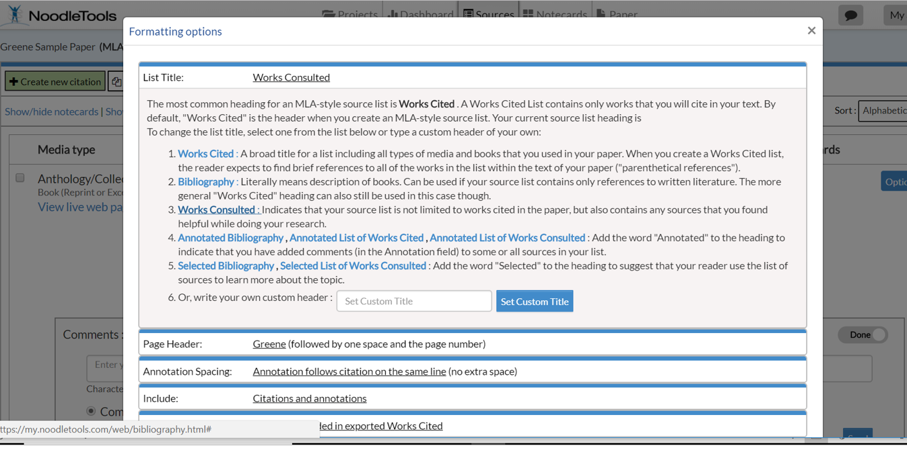

Continued on next page.
Type your last name in the box. Partners will put both names in alphabetical order: Greene and Ognibene
Click on “Set Header” after your name(s) are entered.
Press “Close”

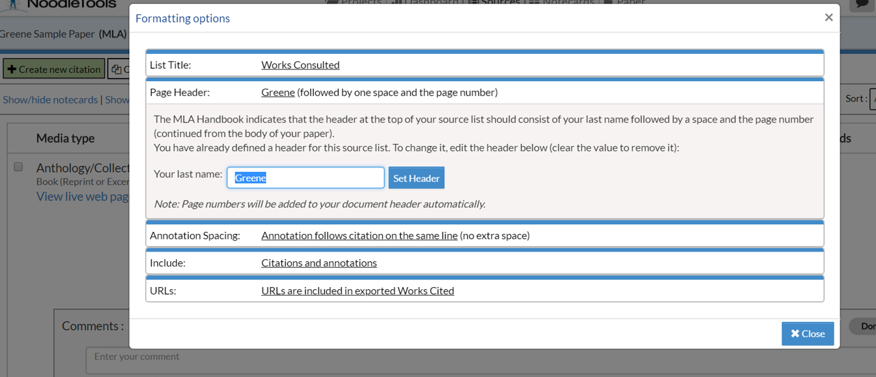

You will be taken back to the “Sources” page.
Select “Print/Export” again then “Print/Export to Word” (this will download your document)
Open your downloaded document and print!

