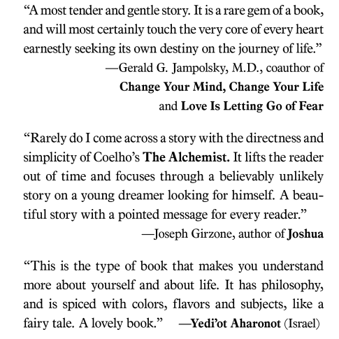

***The Alchemist* Book Reviews**

**al·che·my** (ăl′kə-mē)

A medieval philosophy and early form of chemistry whose aims were the changing of common metals into gold, the discovery of a cure for all diseases, and the preparation of a potion that gives eternal youth. The imagined substance capable of turning other metals into gold was called the philosopher's stone. The potion believed to give eternal life/youth is called the elixir of life. An **alchemist** is someone who practices alchemy.

**Assignment:**

1. Read the following reviews and write a response for each one predicting what you think the book will be about or what it may mean. This is a homework assignment, so you need to use blue or black ink, or you may type your responses.

