**Resources for Illuminated Letters**

[**http://illuminations.ca/letters.html**](http://illuminations.ca/letters.html)

[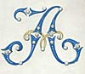](http://illuminations.ca/letter-A.html)[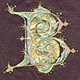](http://illuminations.ca/letter-B.html)[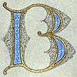](http://illuminations.ca/letter-B-2.html)[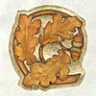](http://illuminations.ca/letter-C.html)[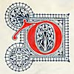](http://illuminations.ca/letter-D.html)[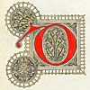](http://illuminations.ca/letter-D-3.html)[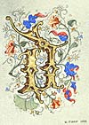](http://illuminations.ca/letter-D-2.html)[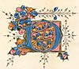](http://illuminations.ca/letter-D-4.html)[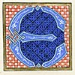](http://illuminations.ca/letter-E.html)[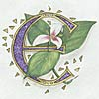](http://illuminations.ca/letter-E-2.html)[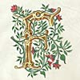](http://illuminations.ca/letter-F.html)[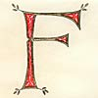](http://illuminations.ca/letter-F-2.html)[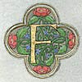](http://illuminations.ca/letter-F-3.html)[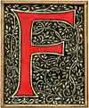](http://illuminations.ca/letter-F-4.html)[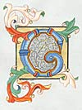](http://illuminations.ca/letter-G.html)[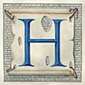](http://illuminations.ca/letter-H.html)[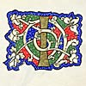](http://illuminations.ca/letter-I.html)[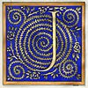](http://illuminations.ca/letter-J.html)[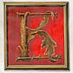](http://illuminations.ca/letter-K.html)[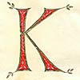](http://illuminations.ca/letter-K-2.html)[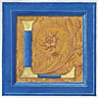](http://illuminations.ca/letter-L.html)[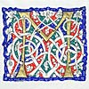](http://illuminations.ca/letter-M.html)[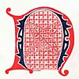](http://illuminations.ca/letter-N.html)[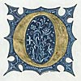](http://illuminations.ca/letter-O.html)[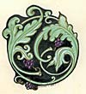](http://illuminations.ca/letter-O-2.html)[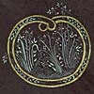](http://illuminations.ca/letter-O-3.html)[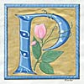](http://illuminations.ca/letter-P.html)[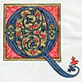](http://illuminations.ca/letter-Q.html)[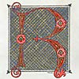](http://illuminations.ca/letter-R.html)[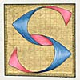](http://illuminations.ca/letter-S.html)[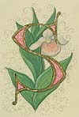](http://illuminations.ca/letter-S-2.html)[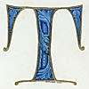](http://illuminations.ca/letter-T.html)[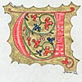](http://illuminations.ca/letter-U.html)[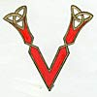](http://illuminations.ca/letter-V.html)[](http://illuminations.ca/letter-W.html)[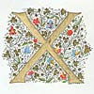](http://illuminations.ca/letter-X.html)[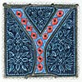](http://illuminations.ca/letter-Y.html)[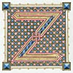](http://illuminations.ca/letter-Z.html)

[**http://www.gettyimages.com/detail/illustration/medieval-illuminated-letters-royalty-free-illustration/163752191**](http://www.gettyimages.com/detail/illustration/medieval-illuminated-letters-royalty-free-illustration/163752191)

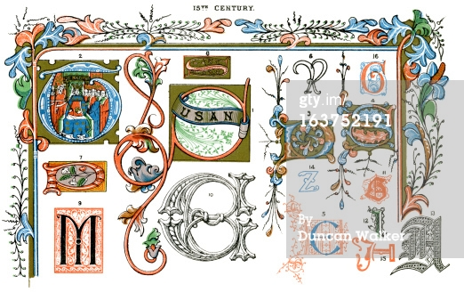

[**Click here for website.**](https://www.google.com/search?q=illuminated+letters+alphabet&safe=active&client=firefox-a&rls=org.mozilla:en-US:official&channel=fflb&biw=1152&bih=553&source=lnms&tbm=isch&sa=X&ei=vKIkVOzmCoGvyAS9lYDACg&ved=0CAYQ_AUoATgU#facrc=_&imgdii=_&imgrc=VtBWyDUKNFsASM%253A%3BMf7ArDhRum9ybM%3Bhttp%253A%252F%252Fclip-arty.co.uk%252Fimages%252Fsource%252FGothic%252FGothic%252520Capitals%252FGothic-capitals-Image%281%29.png%3Bhttp%253A%252F%252Fclip-arty.co.uk%252Findex.php%253F_a%253Dproduct%2526product_id%253D172%3B390%3B275)

