1  Enroll in the class by linking to your class period from the blog. | 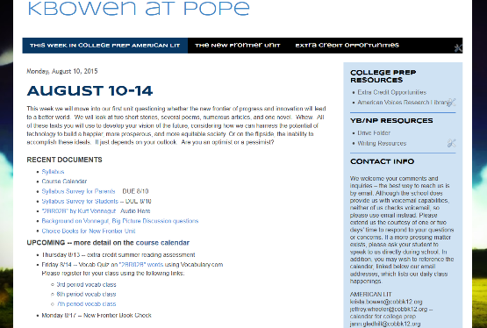 | 2  Register for an account on Vocabulary.com | 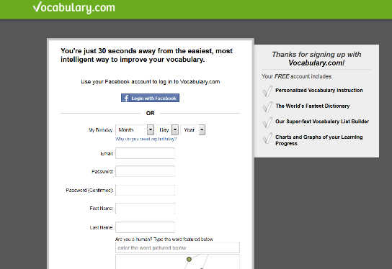
3  Click on My Progress (in the upper right toolbar) to access your American Lit Class | 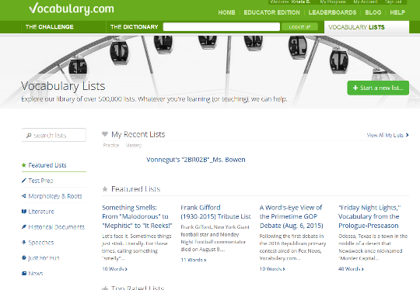 | 4  Click on your class period |  | 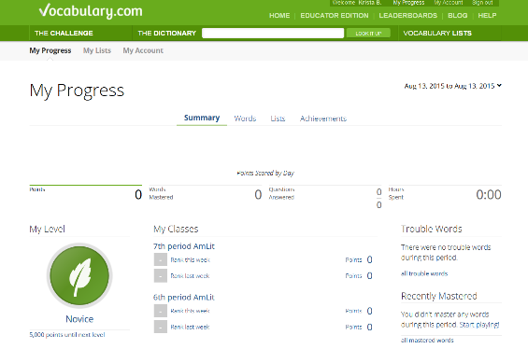
5  Click on Ms. Bowen on the left side | 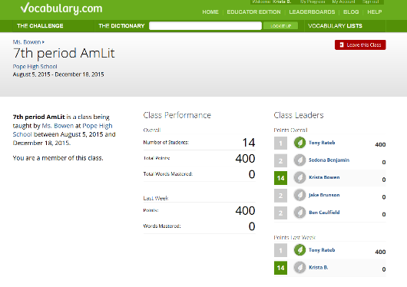 | 6  Click on the vocab list for this week |  | 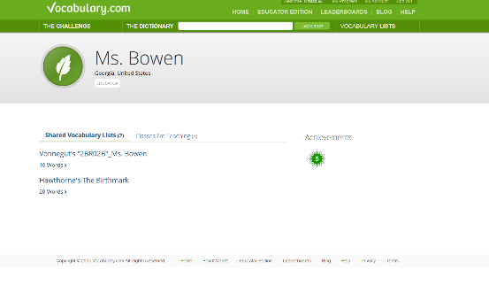
7  Bookmark this list and it will always appear under My Lists and My Progress | 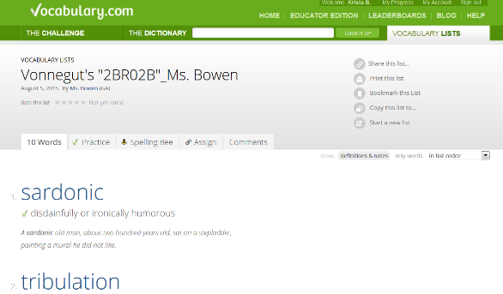 | OR  Click Vocabulary Lists, and search for Bowen, and then bookmark the list

