Welcome to a new school year!
Welcome to Honors Brit Lit with Mrs. Greene! I am looking forward to this new school year and teaching my favorite subject!
I won't be handing out hard copies of my course syllabus--too much paper waste. So here it is for your reading pleasure. It has my grading percentages, your parallel reading titles for this semester, and an explanation about how I grade--all important information:
Books you need to get for Honors Brit Lit Fall Semester:
London
By Edward Rutherfurd
We will read chapters from this book to correlate with the literary periods (for instance, we will only read the chapters that take place during Anglo Saxon and Medieval periods this semester). We will read this book all year, but we will not read all the chapters so don’t panic when you see how big this novel is. Amazon has 224 used copies books for as low as .49 plus shipping. I strongly suggest a hard copy of this book as you will want to annotate as we go over information.
Assignment Date: August 14, Begin reading Chapter 3: “The Rood”
Finish reading Chapter 3: August 29

Complete reading: September 1
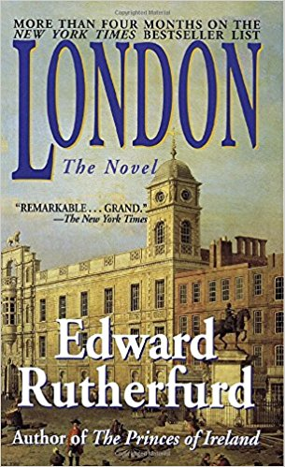
The Year 100
By Robert Lacey and Danny Danziger
I find this book fascinating—it truly gives you a picture of life at the end of the first millennium—that’s right, this is a nonfiction book. Amazon has over 200 used copies at great prices.
Assignment Date: August 21: Begin reading the book.
Finish reading: September 18

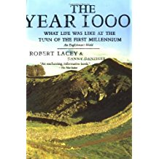
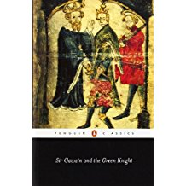
Sir Gawain and the Green Knight
Translated by Brian Stone
- This epic poem has been translated many times, but you need to get the version by Brian Stone because it includes some ancillary essays about Sir Gawain and about King Arthur that you will also need to read. ISBN-10: 0140440925
- ISBN-13: 978-0140440928. Earlier editions might have a different cover—don’t worry about that; just make sure Brian Stone is the translator.
- Assignment Date: October 16
- Finish Reading: November 6

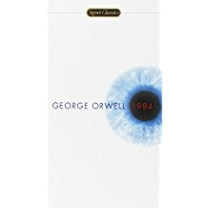
1984
By George Orwell

This book has many different covers—it doesn’t matter which edition you use; since it is not a translated work, any book you get will be the same. Digital or hard copy is okay.
Assignment Date: November 27
Complete reading: December 12

Parallel reading assessments range from quizzes over individual chapters to projects to tests to essays. I will tell you what the assessment will be when I officially assign each title. All of us Brit Lit teachers are firm believers in annotating texts—especially ones you will be held responsible for. Each of these books are an integral part of Brit Lit curriculum so the summative assessment for the novel itself is not the only time you will be using the information you read.
Summer Reading Assessments
You will have an objective test with a few constructed response questions on The Last Kingdom on Tuesday, August 1st. In a couple of weeks, you will write a collaborative essay analyzing one of the characters from The Last Kingdom. In about four weeks, you will write a literary analysis on the other book you read this summer. For the test, you will not be allowed to use the book, but you will be able to use the books when you write the essay.
The Last Kingdom objective and written response test Tuesday, August 1
Grading Percentages will be:
Summative Assessments (tests, essays, projects) 40%
Daily Assessments (quizzes, daily work, homework) 25%
Vocabulary 15%
Final Exam (this class does not have an EOC; the final exam is cumulative) 20%
Vocabulary
We will use Vocabulary.com. Your first list is only 11 words (after this quiz, all lists will have 22-25 words). The first quiz is August 17 for Anglo Saxon List 1.

